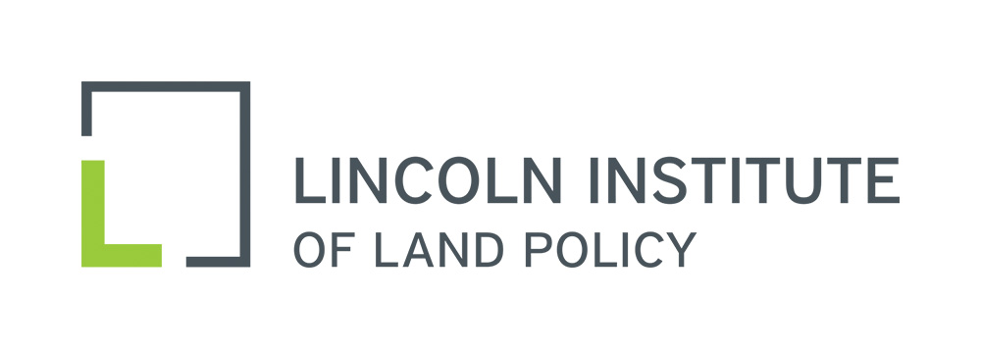

National Conference of State Tax Judges
36th Annual Meeting
Portland, Oregon
September 8-10, 2016

Thursday, September 8, 2016

8:00 - 8:45 a.m. Registration and Breakfast

8:45 - 9:15 a.m. Welcoming Remarks and Introductions
Henry C. Breithaupt, Oregon Tax Court and Conference Chair

9:15 - 10:45 a.m. Case Law Updates
Moderators: Mary E. Gallagher, New York City Tax Appeals Tribunal, and Mary Brennan, Tax Court of New Jersey

10:45 - 11:00 a.m. Break

11:00 a.m. - 12:15 p.m. Case Law Updates, continued

12:15 -1:30 p.m. Lunch
Speaker: Glenn Newman, Greenberg Traurig, LLP
Moderator: Henry C. Breithaupt

1:45 - 3:00 p.m. Case Law Updates, continued

3:15 - 5:15 p.m. Social Activities
Options include a museum tour and a walking tour

6:00 - 7:30 p.m. Welcome Reception

Friday, September 9, 2016

7:30 - 8:30 a.m. Conference Planning Committee Meeting

8:00 - 8:45 a.m. Breakfast

8:45- 10:15 a.m. Big Box Valuation Methodology: Dark vs. Operating Stores
Speaker: Peter F. Korpacz, Korpacz Realty Advisors, Inc.
Moderator: Patrick DeAlmeida, Tax Court of New Jersey

10:15- 10:30 a.m. Break

10:30 a.m. - 12:00 noon Understanding Intangible Assets and Real Estate Value
Speakers: Tim Wilmath, Hillsborough County, Florida
Moderator: Henry C. Breithaupt

12:00 -1:15 p.m. Lunch
Speaker: David Brunori, George Washington University
Moderator: Joan Youngman, Lincoln Institute of Land Policy

1:30-3:00 p.m. Panel on Property Tax Exemptions
Speakers: Evelyn Brody, Chicago-Kent College of Law; John D. Colombo, University of Illinois College of Law; Glenn Newman
Moderators: Mary Brennan and Vito Bianco, Tax Court of New Jersey

3:00- 3:15 p.m. Break

3:15- 4:15 p.m. Panel on Property Tax Exemptions, continued

6:00 p.m. Conference Banquet

Saturday, September 10, 2016

8:15- 9:00 a.m. Breakfast

9:00- 11:45 a.m. State Tax Program
Speakers: Richard Pomp, University of Connecticut School of Law, and Kirk Stark, University of California – Los Angeles School of Law
Moderator: Henry C. Breithaupt

11:45 a.m. – 12:00 noon Closing Remarks
Henry C. Breithaupt, Conference Chair

12:00 noon Conference Adjourns

