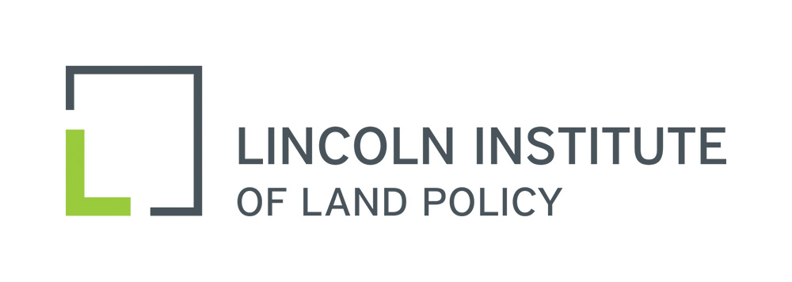
National Conference of State Tax Judges
37th Annual Meeting
Cambridge, Massachusetts
September 7-9, 2017

Dirk Giseburt, Joseph Henchman, David Herzig:
Retroactivity: Constitutional Issues and Controversies

